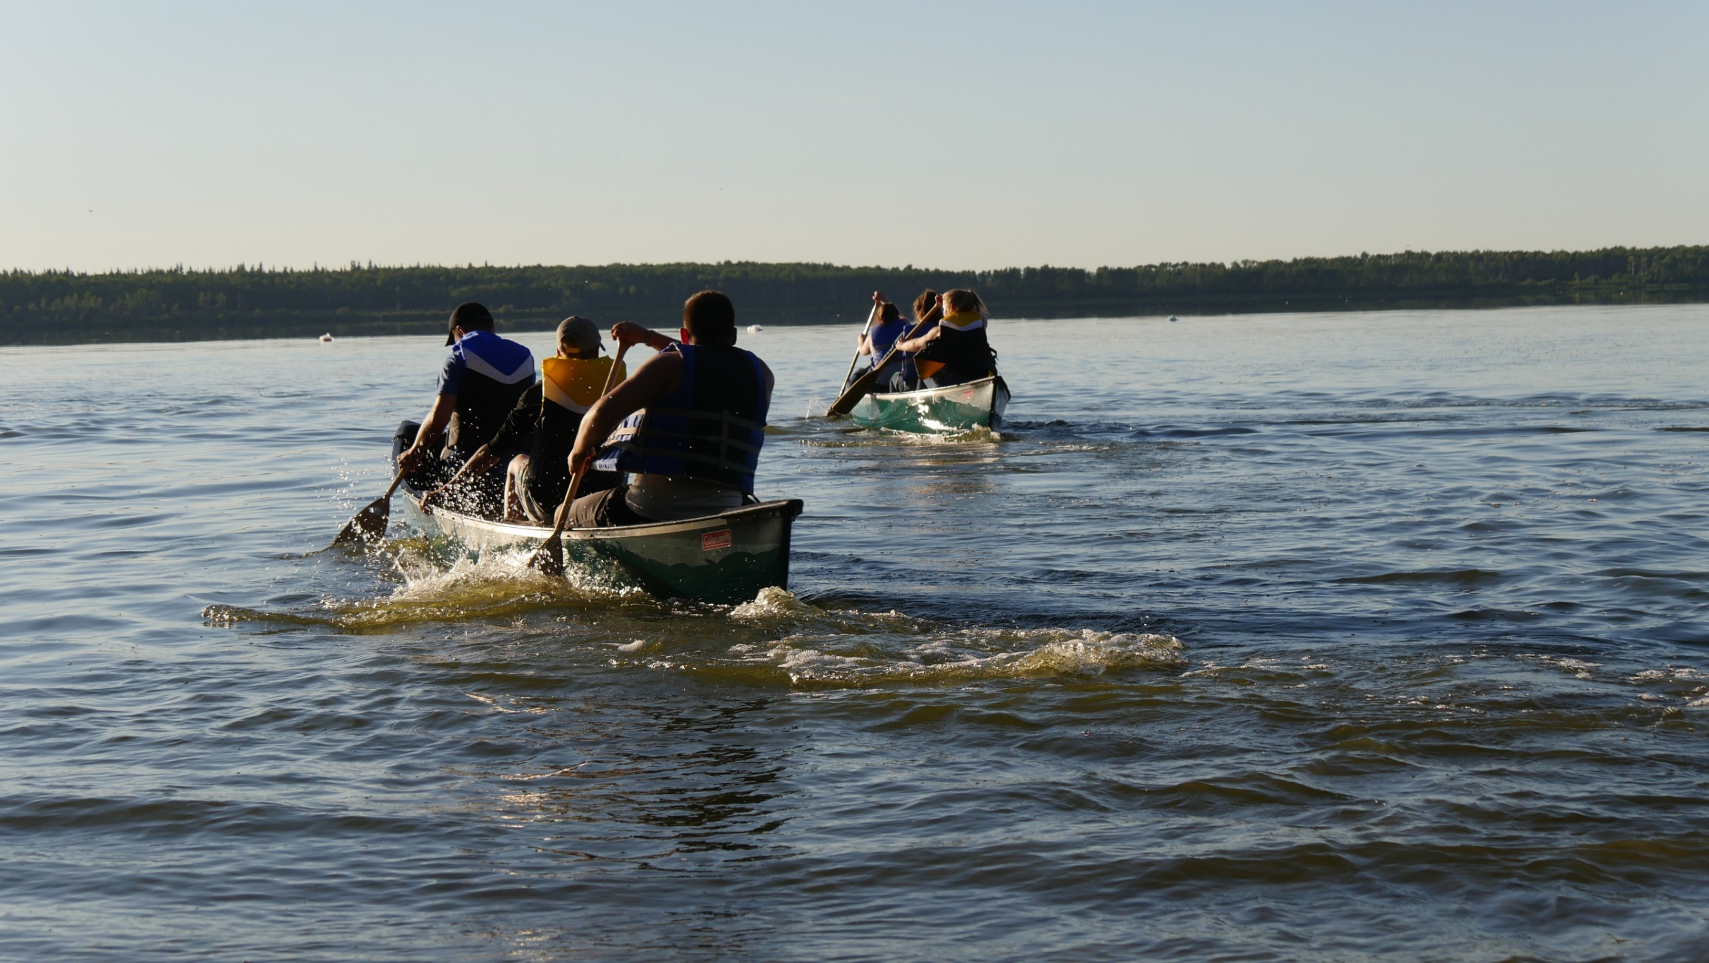

* Musical Instrument
* Bible
* Rosary
* Journal & Pen
* Small Board Game

Optional Items

* Labeled refillable water bottle
* Two towels
* Toiletries (don’t forget soap)

Other

* Pillow
* Sleeping bag
* Blanket
* Twin Sheet (optional)

Note: Campers sleep in cabins on bunk beds.

To Sleep

* Hat
* Cheap Sunglasses
* Sunscreen & Bug Spray
* Sweatshirt & warmer coat
* Hooded Rain Coat & boots
* Sandals or flip flops
* Swim suit (one piece for ladies & knee length shorts for gents.)
* Summer dress or dress shirt & nice jeans
* Clothing according to camp specific list (see list below)

To Wear

* Nut Free Snack

To Share

## What to Bring

Clothing – Lead Week (Sr. High)



* Service project outfit (may get paint on it)
* Active wear X2 (including running shoes)
* Everyday clothes X3
* Summer dress or dress shirt & nice jeans
* Junk food
* Any type of knife
* Lighters
* Pets (no penguins)
* Valuables (jewelry, etc.)
* Electronics (Cellphone, ipad, X-box, etc.)
* Cigarettes, drugs, alcohol or memorabilia.
* Books or magazines from home.
* Spaghetti straps, super short shorts, bikinis (any clothes that require frequent adjusting to be comfortable or keep in place)

Note: we ask that shorts be longer than the longest shirt/sweater you bring.

## What Not to Bring



* Messy game outfit X2 (T-shirt, shorts or pants & shoes) that can be ruined/stained.
* Service project outfit (may get paint on it)
* Active wear X2 (including running shoes)
* Everyday clothes X3
* Summer dress or dress shirt & nice jeans
* Messy game outfit (T-shirt, shorts or pants & shoes) that can be ruined/stained.
* Active wear X2 (including running shoes)
* Everyday clothes X2
* Summer dress or dress shirt & nice jeans

Clothing – Gr. 4 – 6 Camp



Clothing – Jr. High Camp

